# **Chapter 4: Implementation**

**4.1 Introduction**

* It is the 3rd stage of the software development life cycle. A set of syntax guideline and rules that define the way how code should be written to create application is **Coding**. There are many programming language to create application, and websites. Coding helps humans to interact with machine and instruct them. After designing phase, coding and implementation phase comes under third phase of System Development Life Cycle.

**4.2 Programming Language**

* For doing this project, I have choose Object Oiented Programming (OOP) PHP for working on backend. It is widely used open source scripting language to develop websites. And also choose My SQl for storing date and values into databases. The main reason why I choose PHP was because of its integration with many database such as MY SQL, Oracle etc. it can aslo handle multiple forms.

**4.3 Design Pattern**

* For doing this project, I have used MVC design pattern. The model view controller configuration design determines that an application comprise of an information display, introduction data, and control data. the main reason why I choose MVC design pattern was because It is faster development process which is suitable for developing this project.It has has various capacity to give different perspectives.It helps to restores the information without organizing.

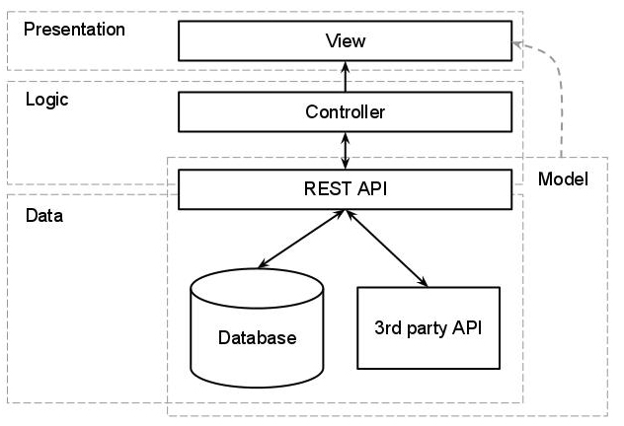

***Fig 4.3.1 MVC Pattern***

## **4.4 Tools Used**

* Tools which are used to develop my project are listed below:-
* Operating suystem as an **Windows 10.**
* Sublime Text 3 as code editor tool to manipulate codes.
* Google’s Chrome as browsers.
* XAMPP as host server and to manage client.

**4.5 Code and Screenshots**

**-** Below are screenshots of webpage with their frontend and backend code.

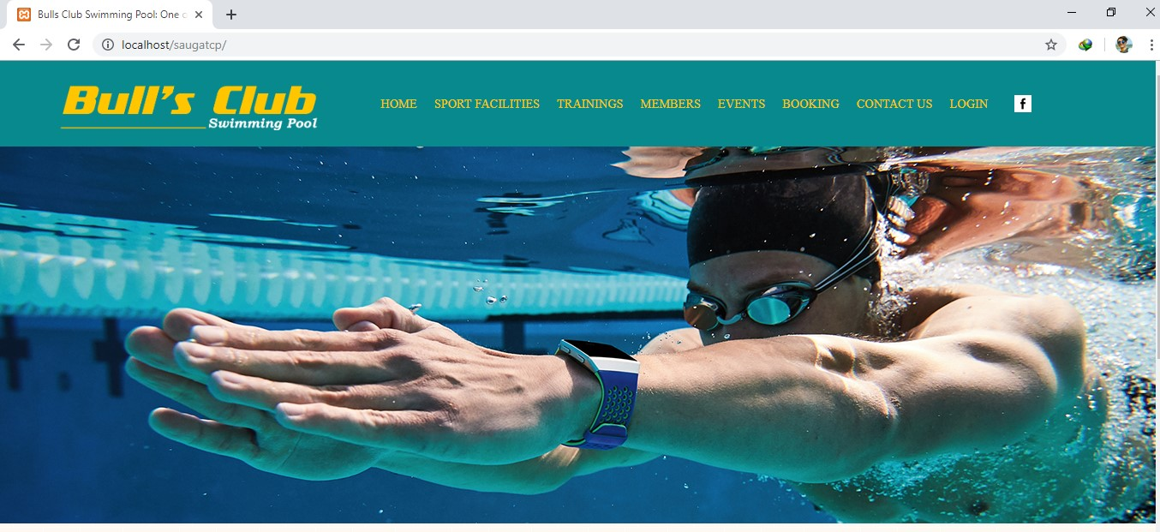

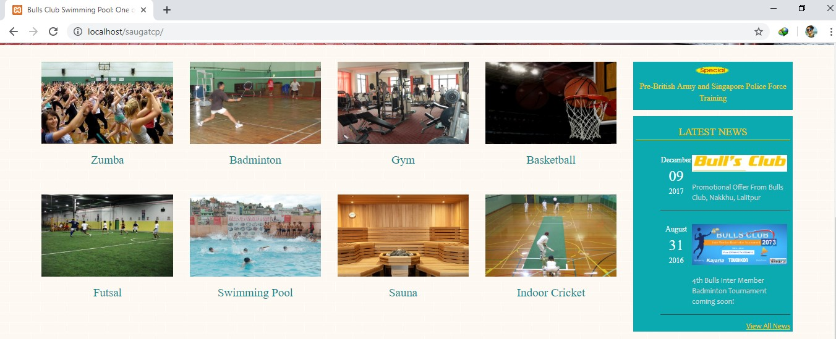

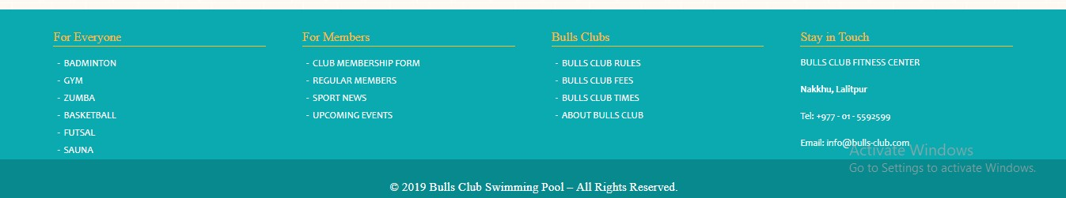

*Screenshot: Home Page*

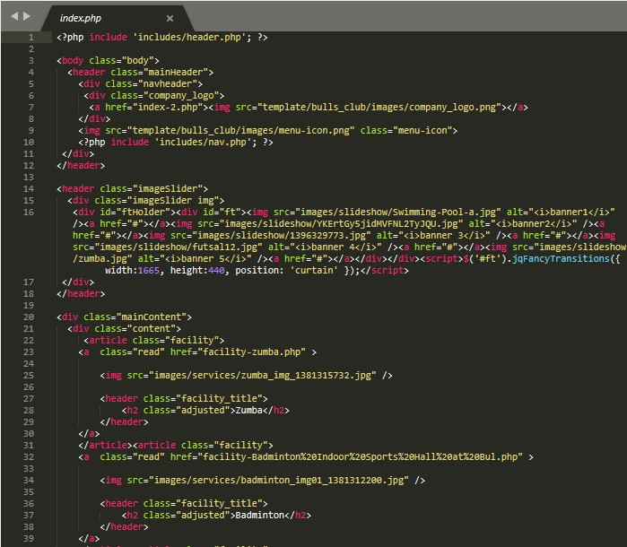

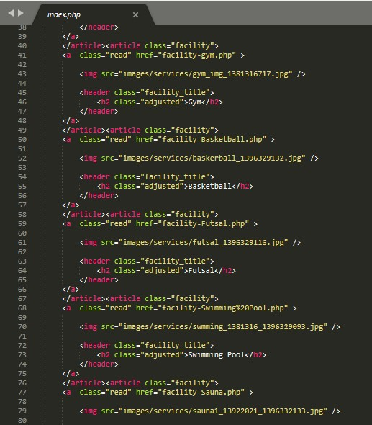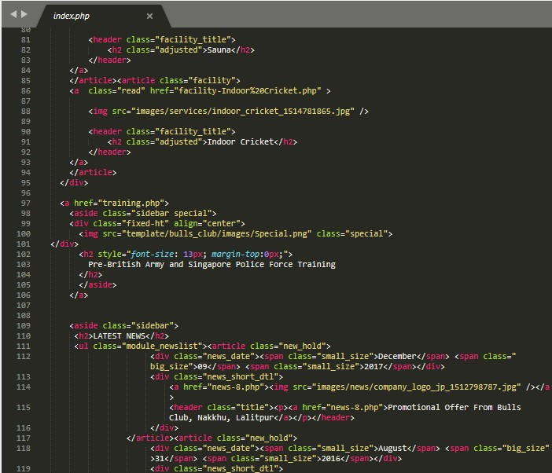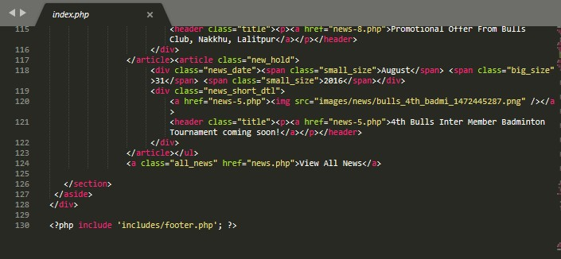

*Screenshot: Code of homepage*

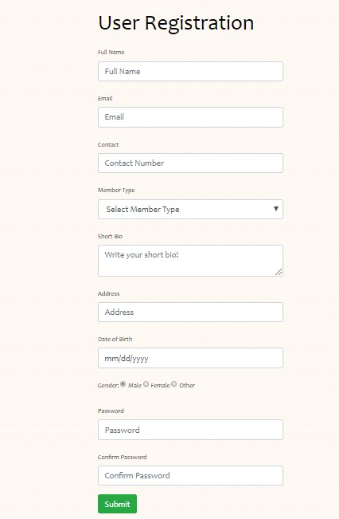

*Screenshot: User Registartion*

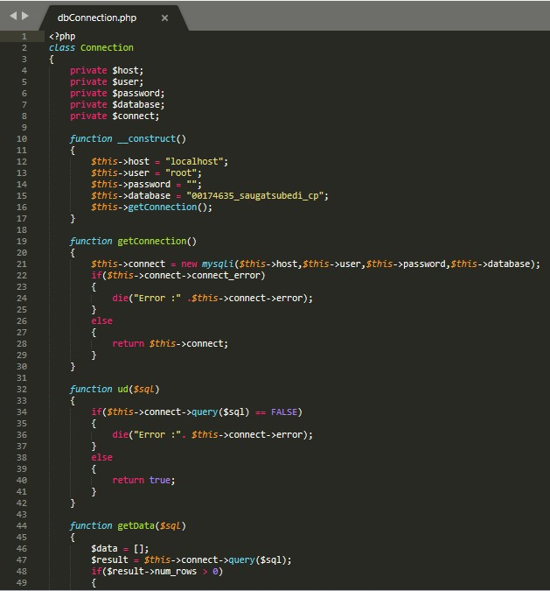

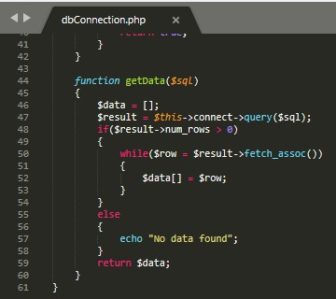

*Screenshot: Database Connection*

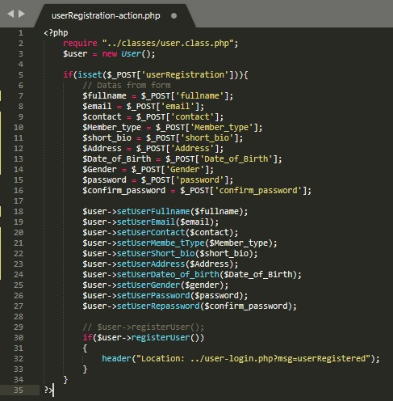

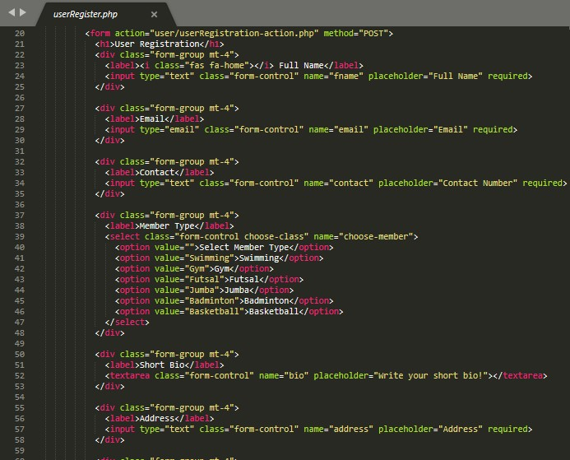

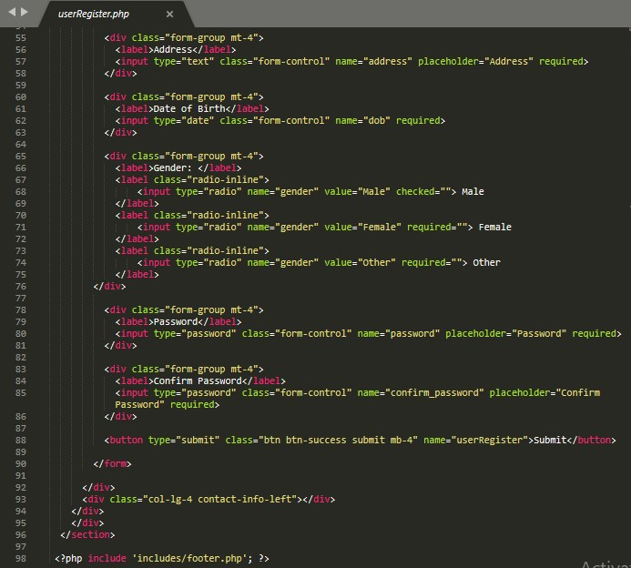

*Screenshot: code of User Registartion*

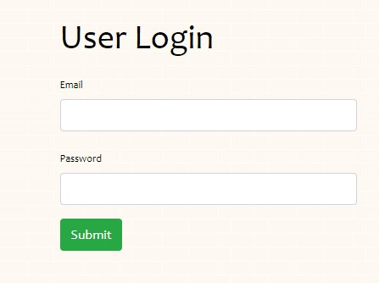

*Screenshot: User Login*

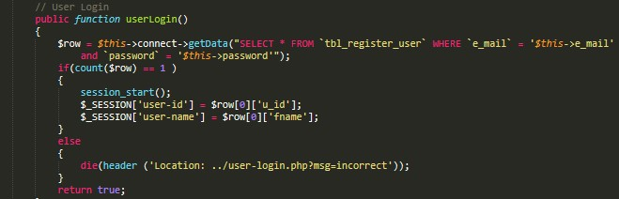

*Screenshot: User Login Code*

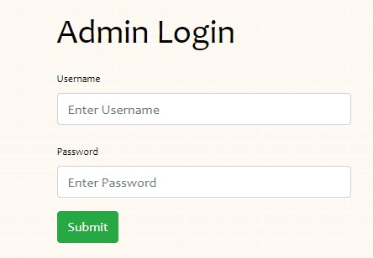

*Screenshot: Admin Login*

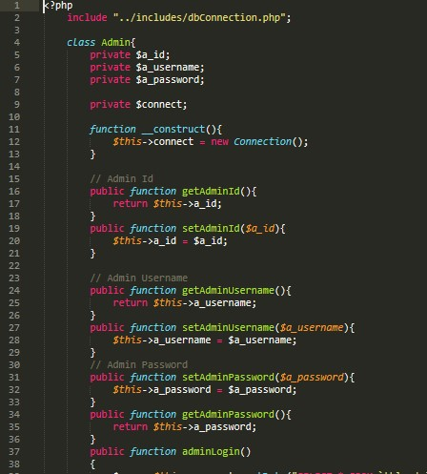

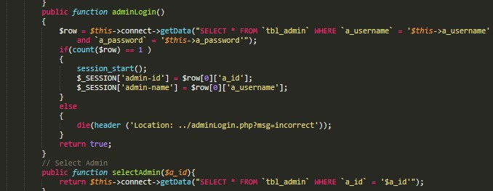

*Screenshot: Admin Login Code*

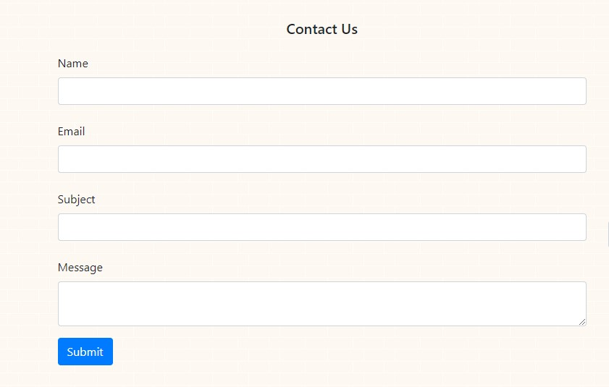

*Screenshot: Contact Us Form*

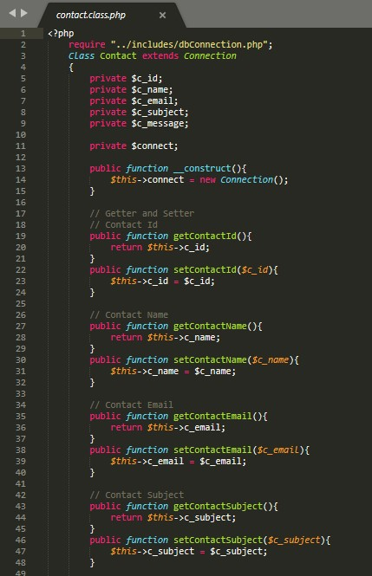

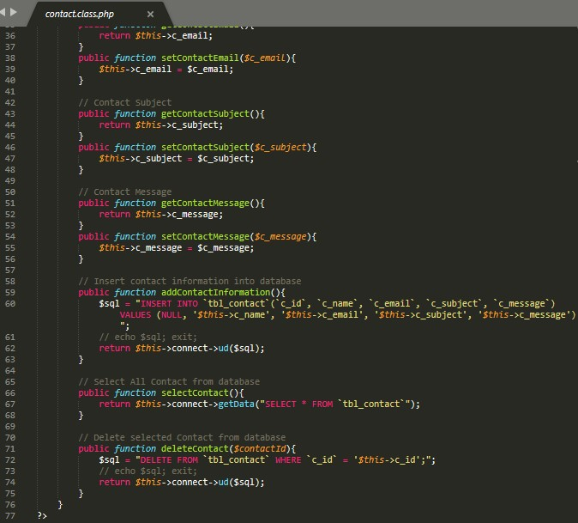

*Screenshot: Code of contact Us*

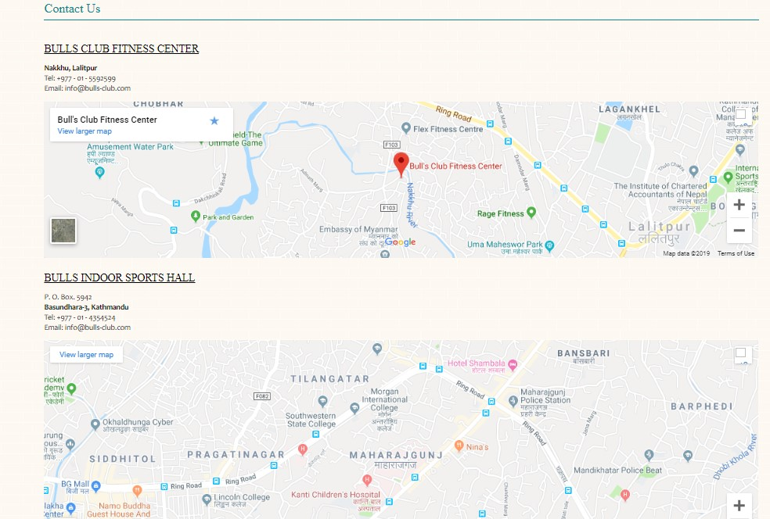

*Screenshots: Contact Us detail and mape*

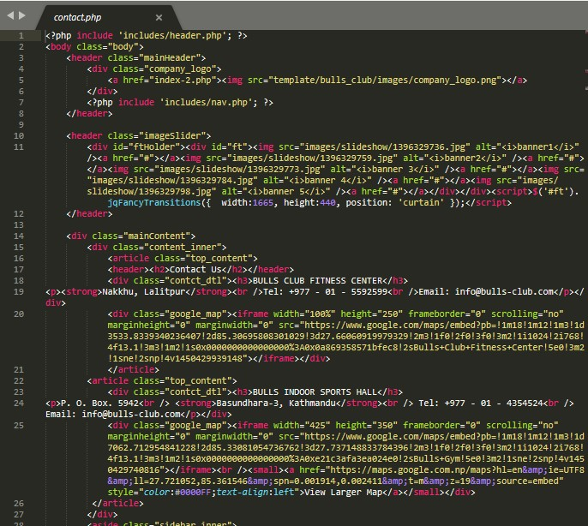

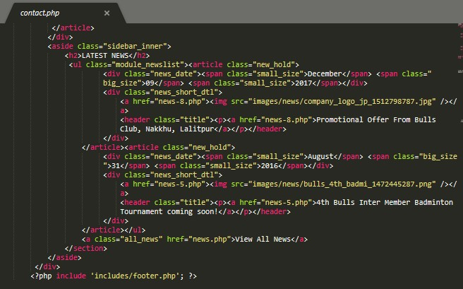

*Screenshot: Contact Us cod*

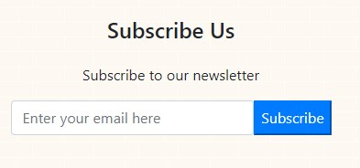

*Screenshot: Subscribe Form*

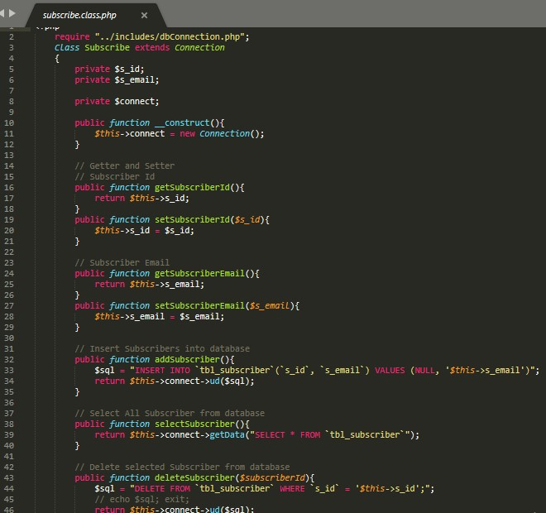

*Screenshot: Subscribe code*

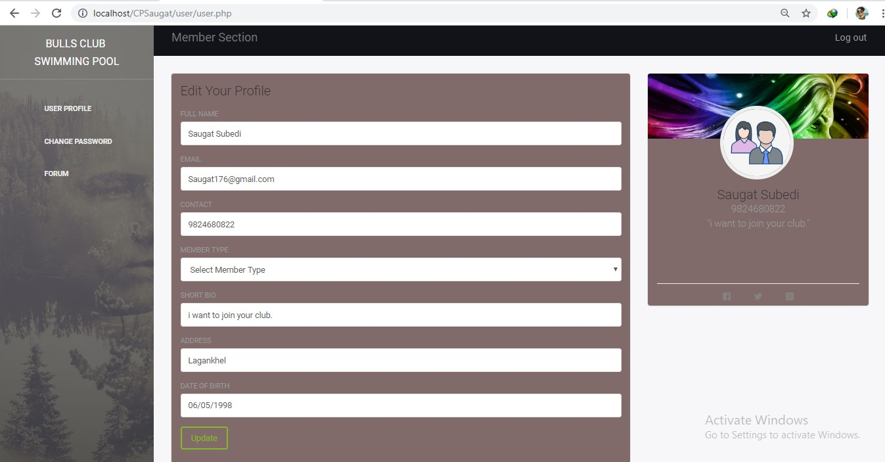

*Screenshot:* User dashboard and User Update Form

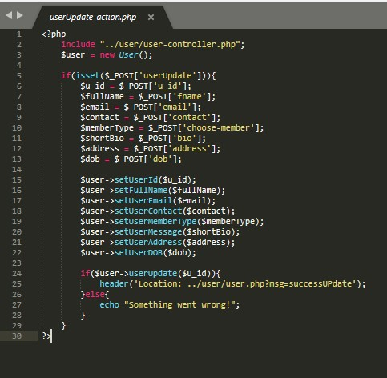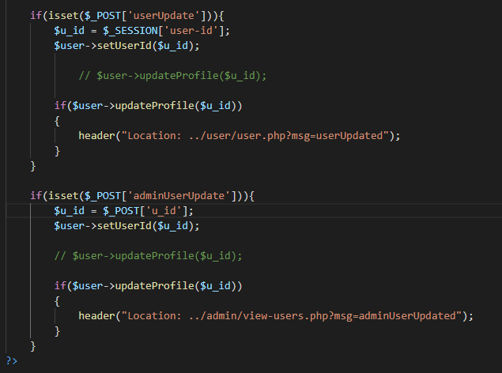

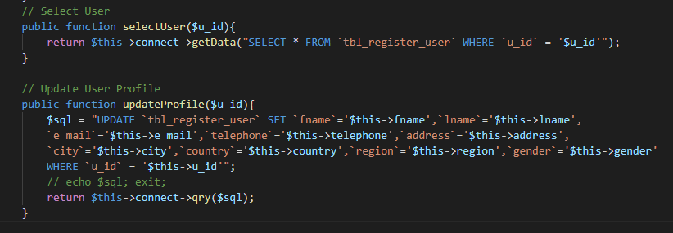

*Screenshot: User update code*

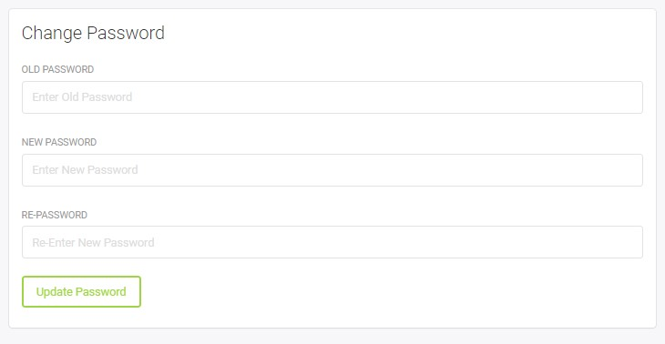

*Screenshot: User Password Change Form*

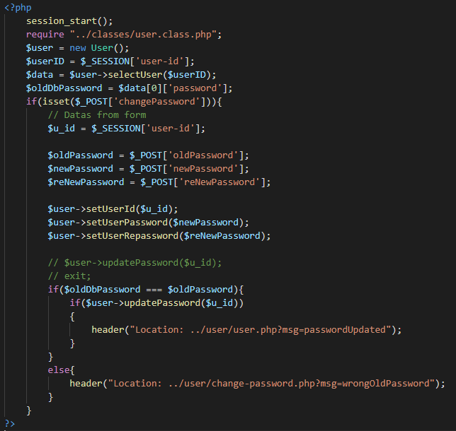

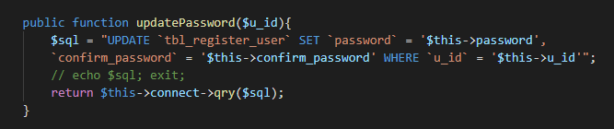

*Screenshot: user password change code*

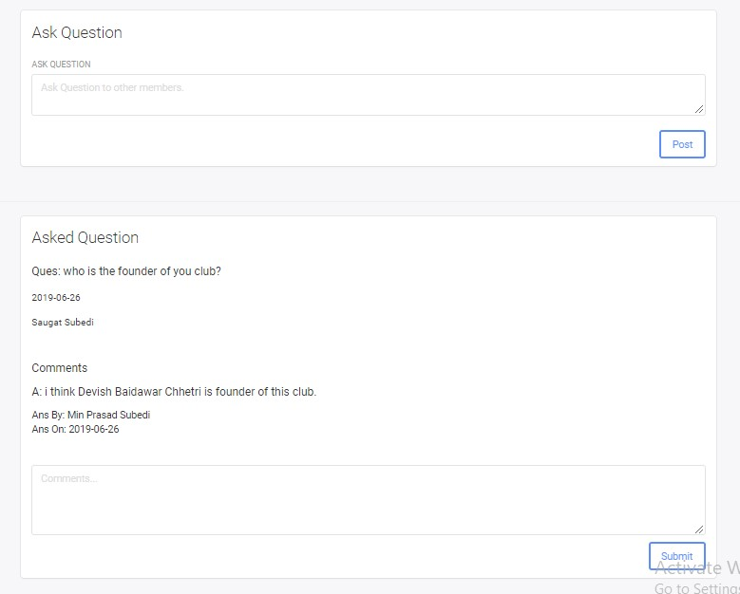

*Screenshot: Users forum*

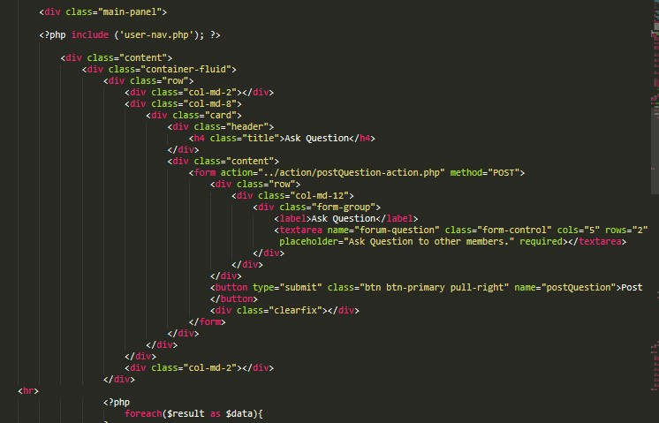

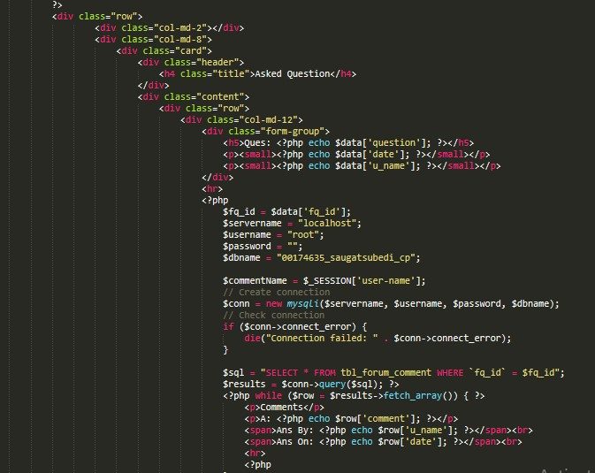

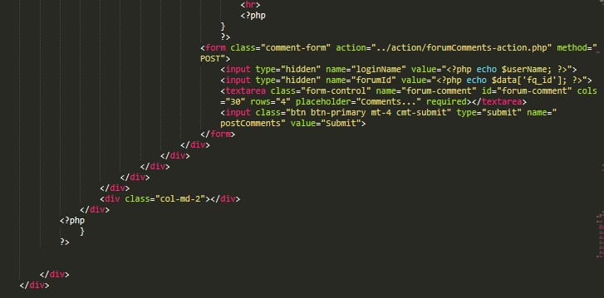

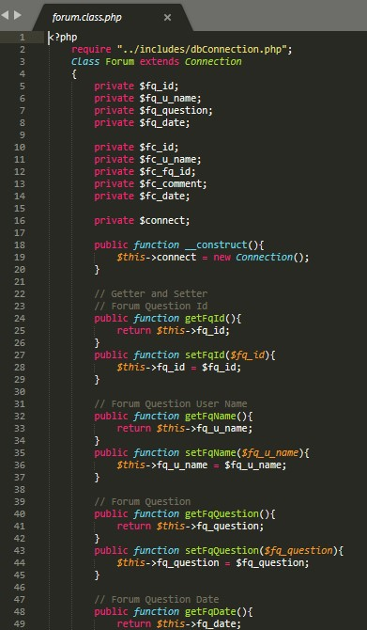

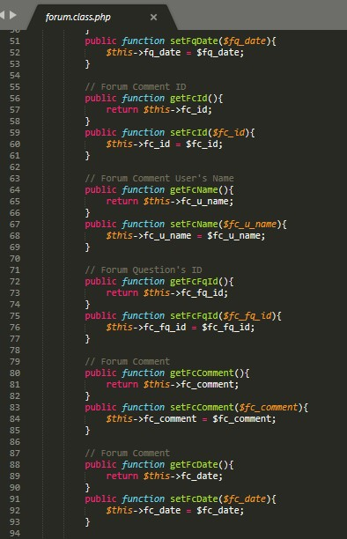

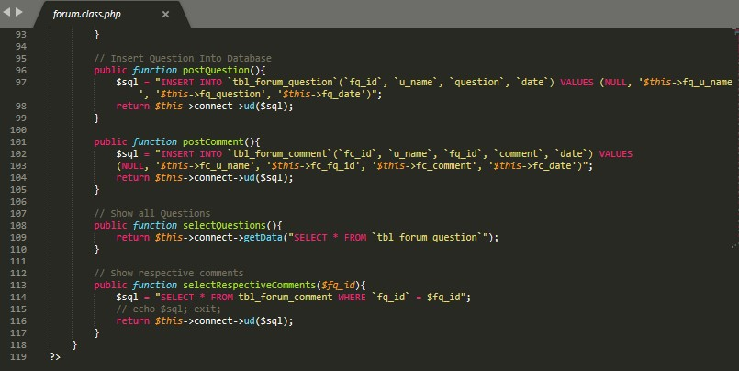

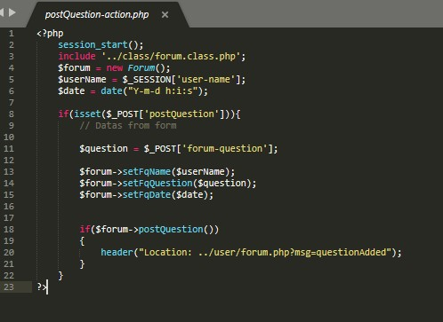

*Screenshot: Forum Question Code*

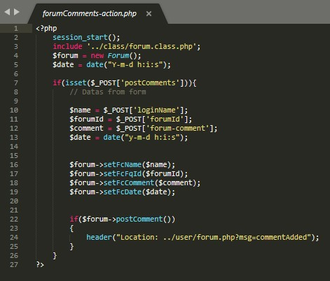

*Screenshot: Forum Comments Code*

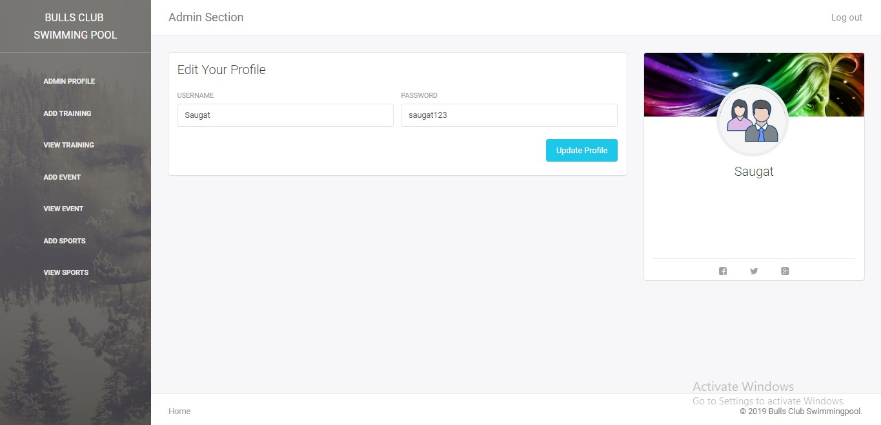

*Screenshot: Admin Dashboard Form*

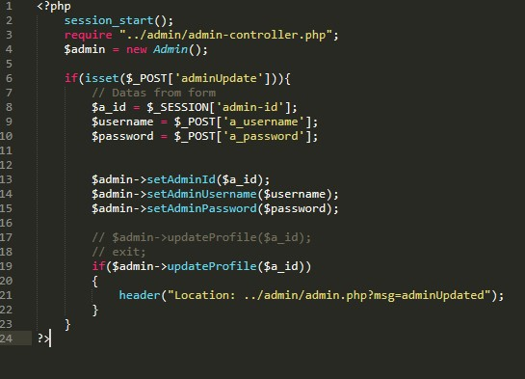

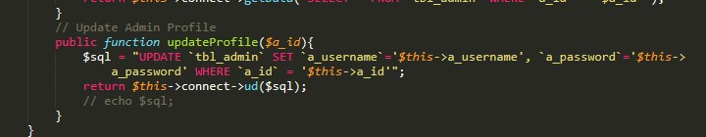

Screenshot:- Update admin profile code

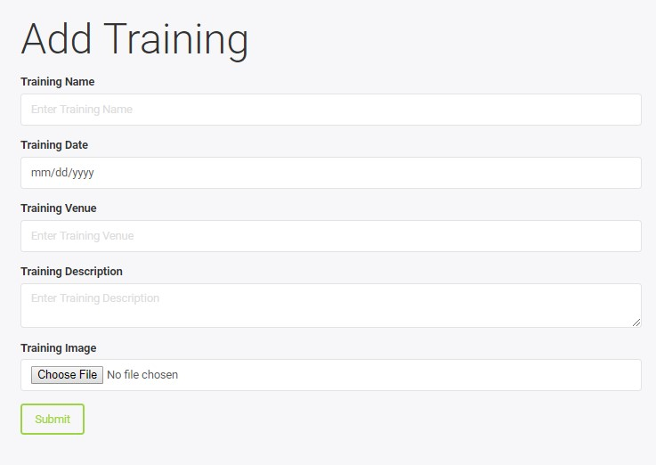

Screenshots: Add training form

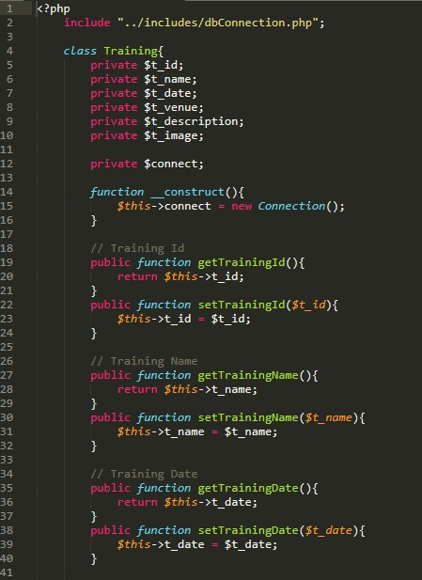

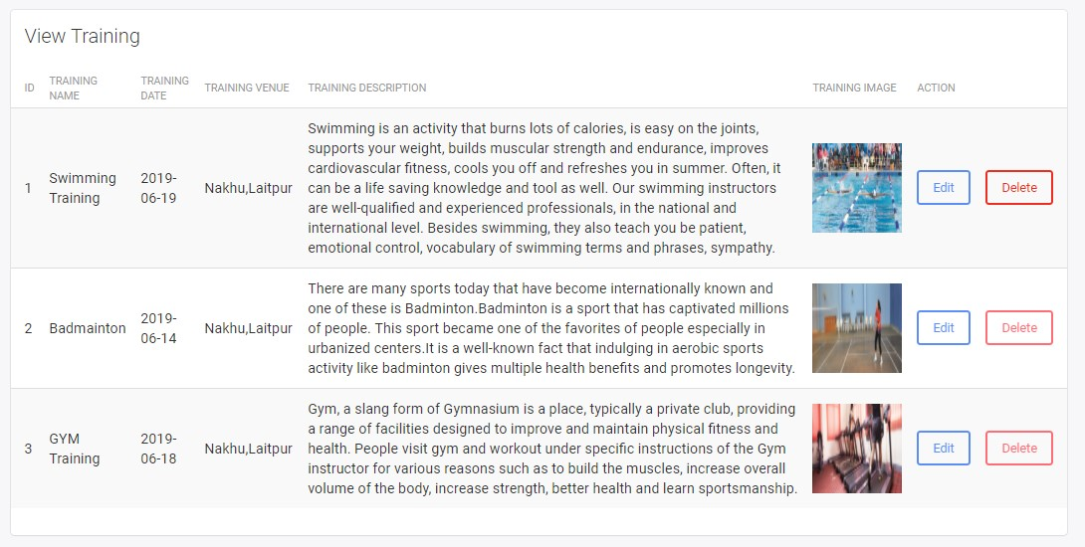

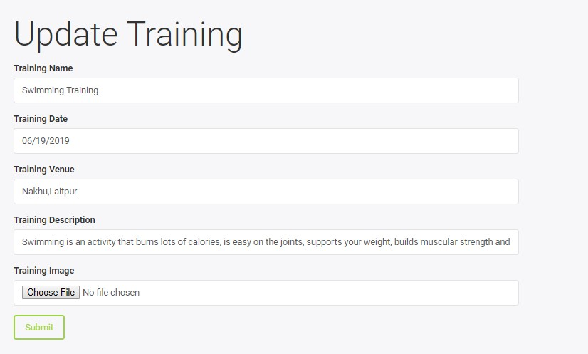

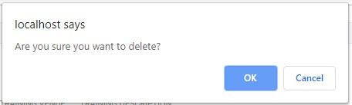

*Screenshots:Add Update and Delete Training*

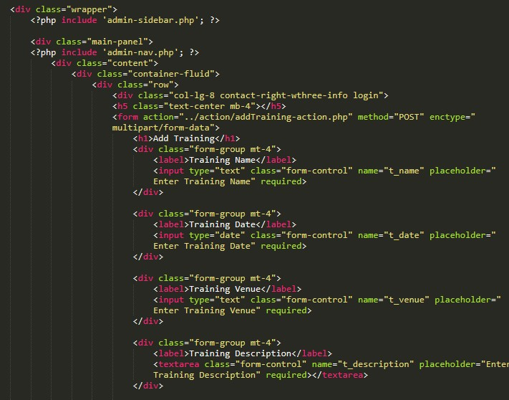

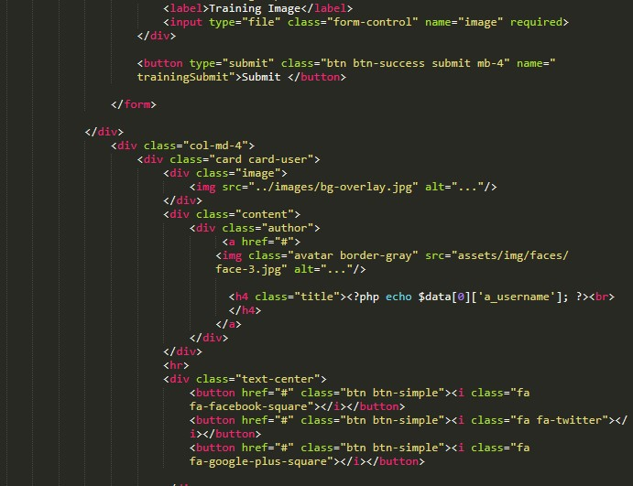

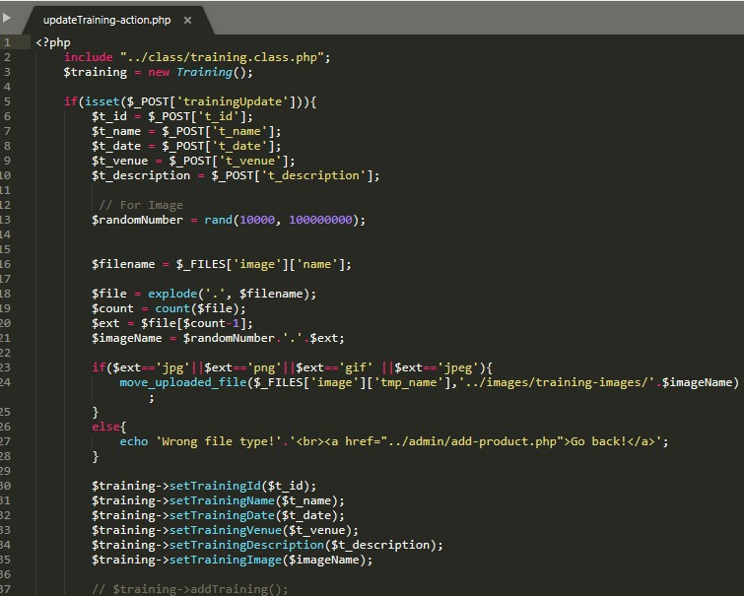

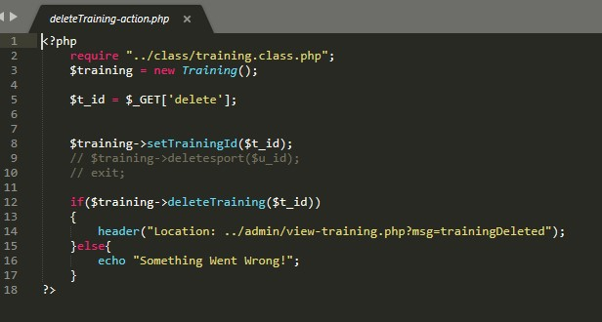

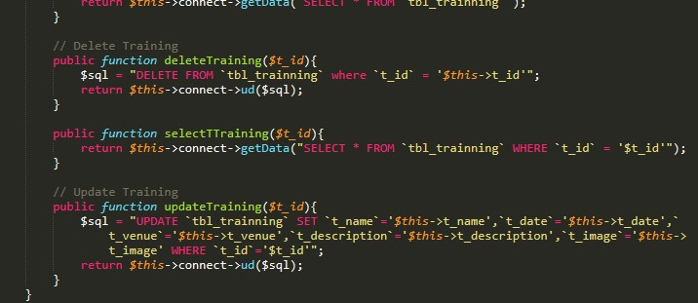

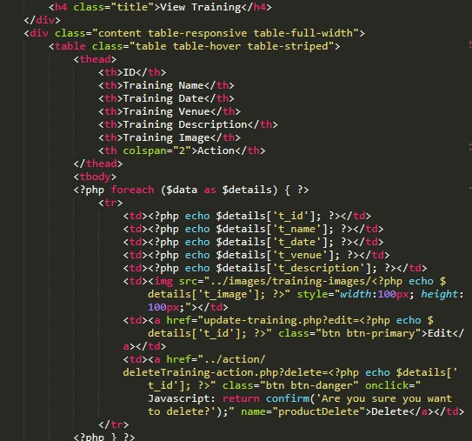

Screenshots: view,add and delete code

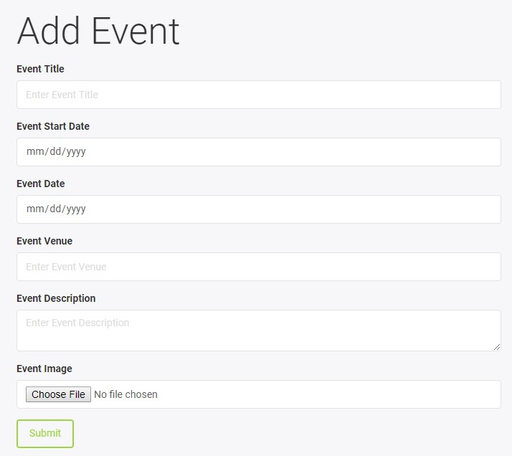

*Screenshot: Add Event Form*

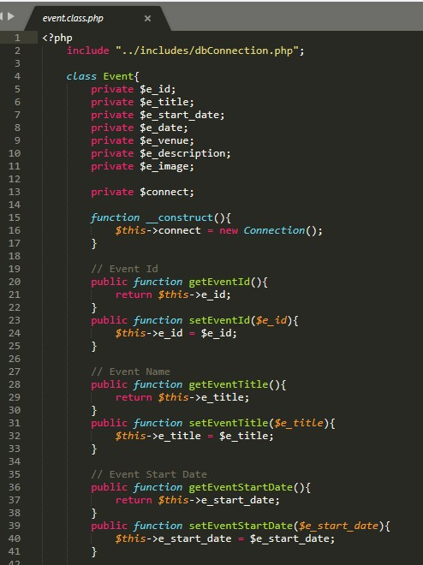

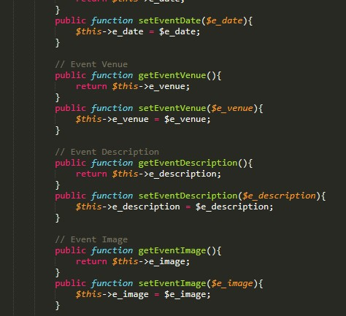

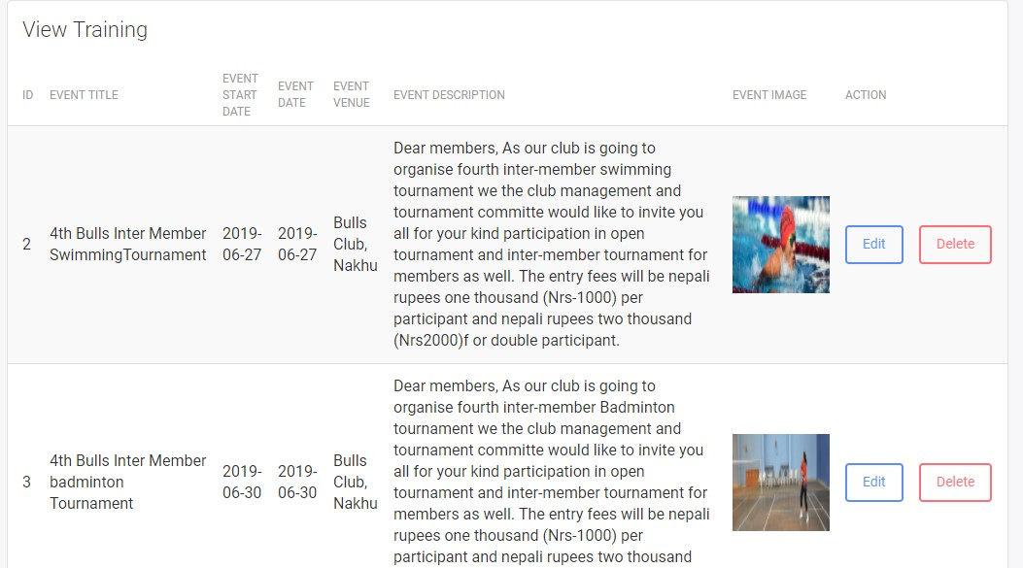

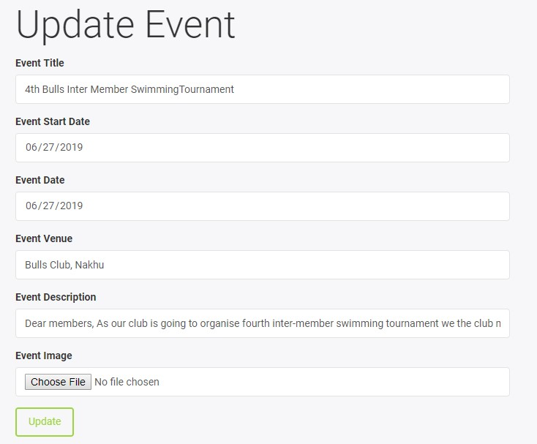

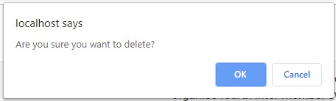

*Screenshots:Add Update and Delete event form*

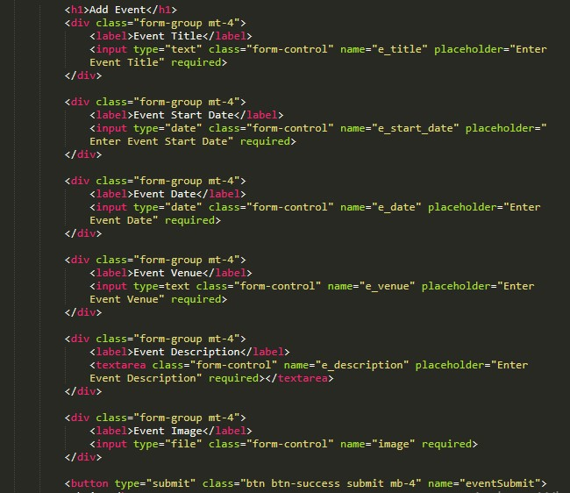

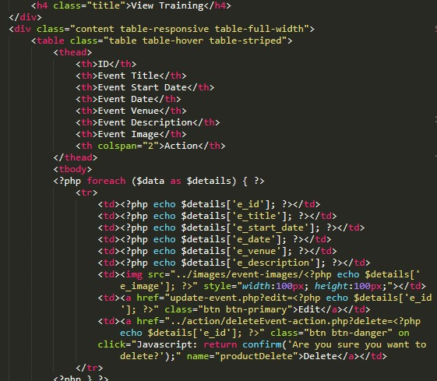

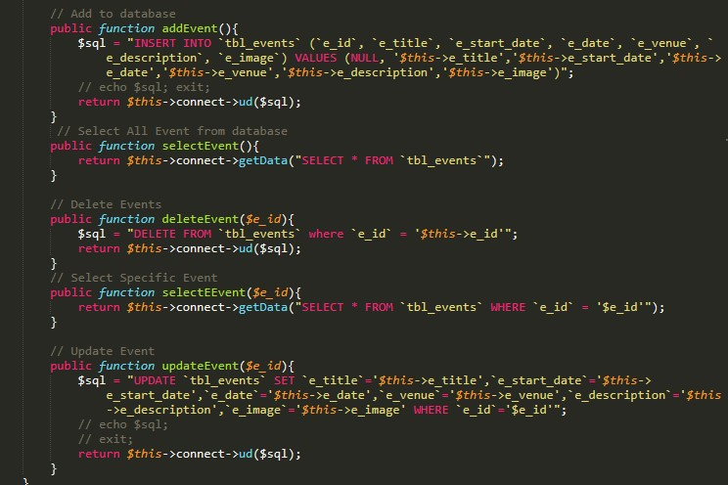

Screenshots: view,add and delete code

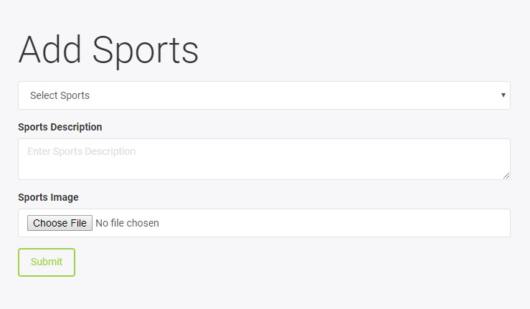

*Screenshots: Add sports form*

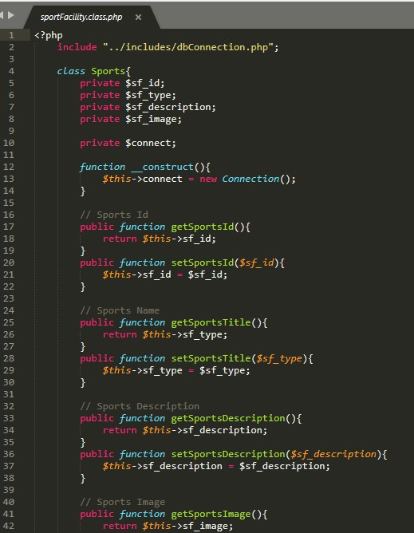

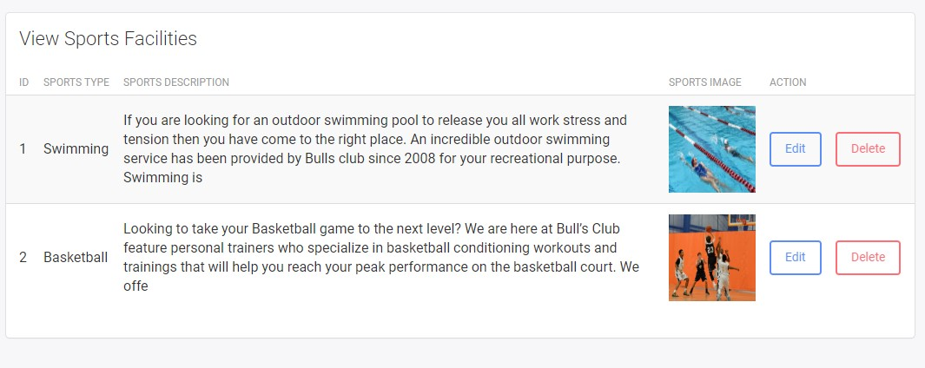

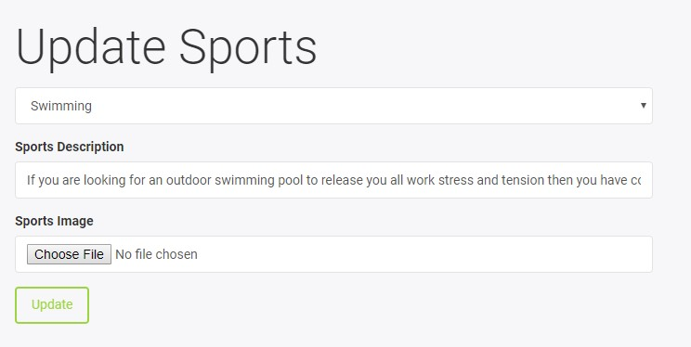

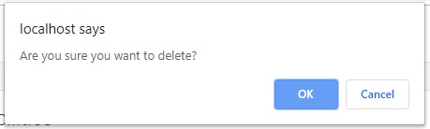

*Screesnshots: add update and delete form*

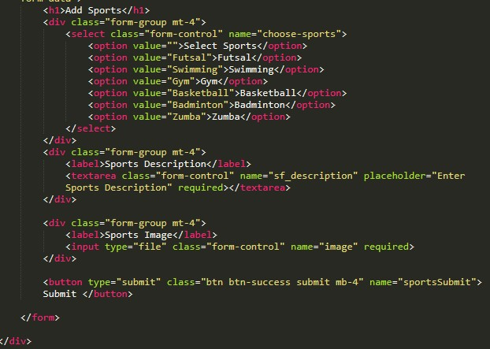 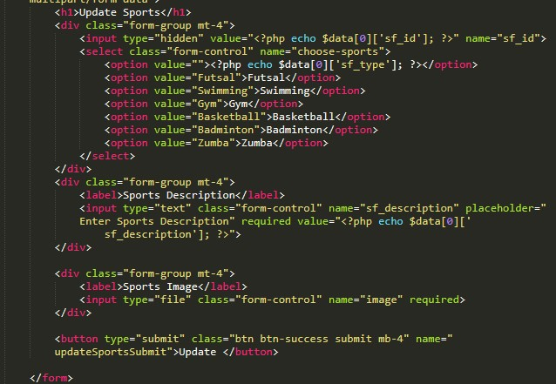 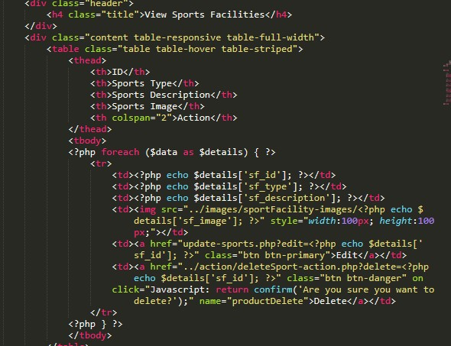 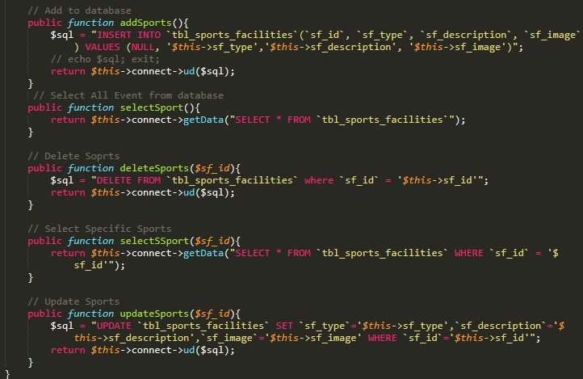

*Screenshots: view,add and delete code*

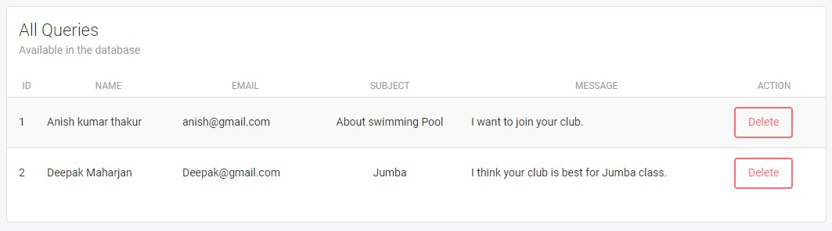

*Screenshots: View Queries*

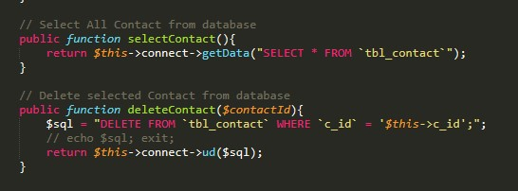

*Screenshots: view and delete code*

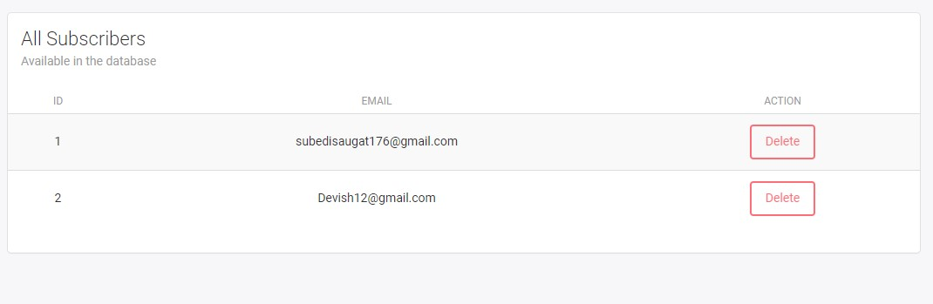

*Screenshots:view user subscribers*

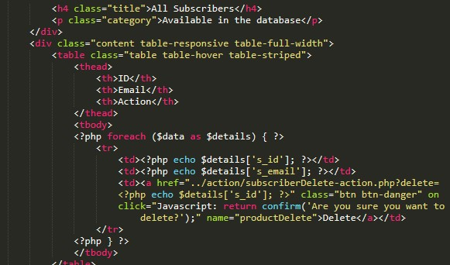

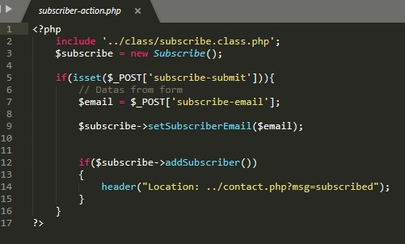

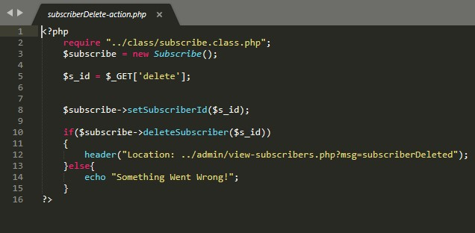

*Screenshots: view subscibe code*